Neustar Amla Hair Oil (200ml) MRP
₹166.00

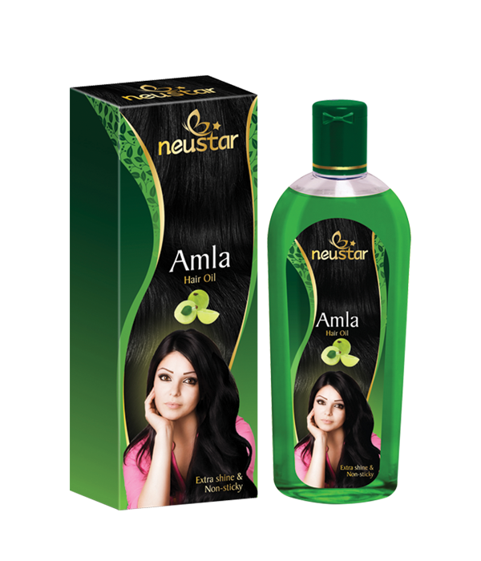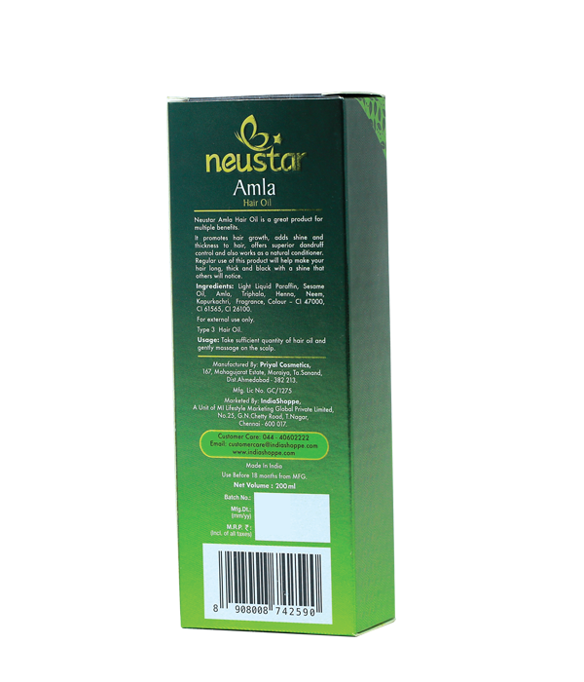

Product Description:
Neustar Amla Hair Oil is a great product for multiple benefits. It promotes hair growth, adds shine and thickness to hair, offers superior dandruff control and also works as a natural conditioner. Regular use of this product will help make your hair long, thick and black with a shine that others will notice.
Net Content: 100ml

Directions for use: Take sufficient quantity of hair oil and gently massage on the scalp.

Ingredients: Light Liquid Paraffin, Sesame Oil, Amla, Triphala, Henna, Neem, Kapurkachri, Fragrance, Colour - CI 47000, CI 61565, CI 26100.

Storage: Store in a cool and dry place, away from direct sunlight. For external use only.

Manufactured by: Priyal Cosmetics, 167, Mahagujarat Estate, Moraiya, Ta. Sanand, Ahmedabad - 382 213. Mfg. Lic. No .- GC/1275

Marketed by: IndiaShoppe, A Unit of MI Lifestyle Marketing Global Private Limited, No.25, G.N.Chetty Road, T.Nagar, Chennai - 600017, Tamil Nadu

Shelf Life: Use before 18 months from the date of manufacture.

Additional Information:

Neustar Amla Hair Oil is formulated to promote hair growth, reverse greying, and add shine and thickness to your hair. Regular use of this oil ensures long, thick, and shiny hair that others will notice.
Used for: Promoting hair growth, reversing greying, adding shine and thickness, and maintaining scalp health.
Benefits: Neustar Amla Hair Oil helps in promoting hair growth and prevents greying of hair. It adds shine and thickness, making your hair look healthy and vibrant. Regular application prevents dandruff, reduces hair fall, and acts as a natural conditioner.
Disclaimers: For external use only.
ON&ON Maha Bhringraj Herbal Hair Oil (200ml) MRP₹430.00
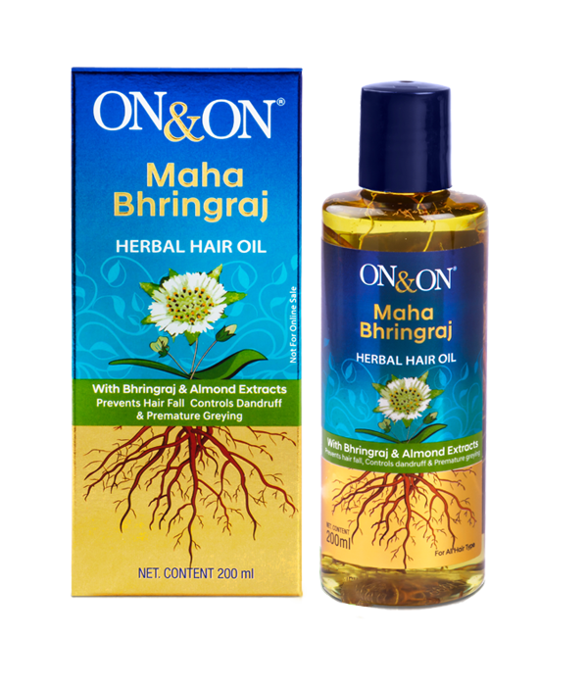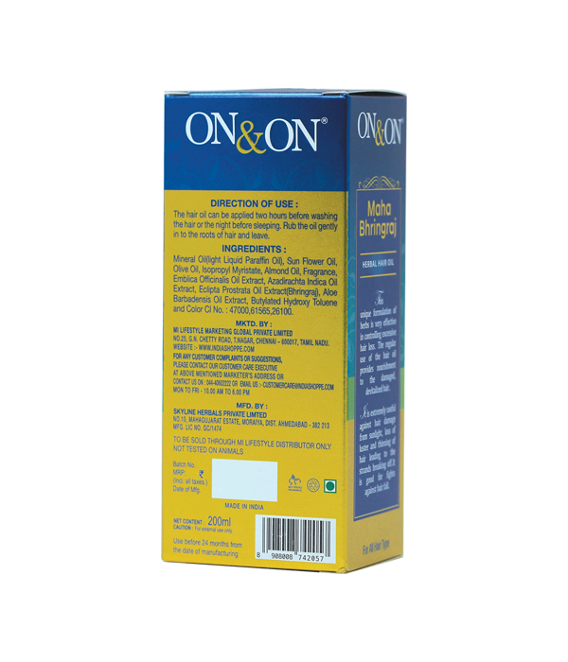

Product Description:
This unique formulation of herbs is very effective in controlling excessive hair loss. The regular use of the hair oil provides nourishment to the damaged, devitalized hair. It is extremely useful against hair damage from sunlight, loss of lustre and thinning of hair leading to the strands breaking off. It is good for fights against hair fall.

Net Content: 200ml
Directions for use: The hair oil can be applied two hours before washing the hair or the night before sleeping. Rub the oil gently in to the roots of hair and leave.

Ingredients: Mineral Oil(light Liquid Paraffin Oil), Sun Flower Oil, Olive Oil, Isopropyl Myristate, Almond Oil, Fragrance, Emblica Officinalis Oil Extract, Azadirachta Indica Oil Extract, Eclipta Prostrata Oil Extract(Bhringraj), Aloe Barbadensis Oil Extract, Butylated Hydroxy Toluene and Color CI No: 47000,61565,26100.

Storage: Store in a cool, dry place away from direct sunlight. Keep out of reach of children. For external use only.

Manufactured by: Skyline Herbals Private Limited, No. 10, Mahagujarat Estate, Moraiya, Dist. Ahmedabad-382213. Mfg Lic No Gc/1474

Marketed by: Mi Lifestyle Marketing Global Private Limited. No.25, G.N.Chetty Road, T. Nagar, Chennai-600017, Tamil Nadu.

Shelf Life: Use before 24 months from the date of manufacture.

Additional Information: ON&ON Maha Bhringraj Herbal Hair Oil is renowned for its ability to nourish and strengthen hair, making it smoother, lustrous, and healthier. Its herbal formulation ensures it is gentle on the scalp, promoting overall hair health without any adverse effects. Ideal for anyone seeking a reliable solution to hair concerns, it stands out for its authentic herbal ingredients and rejuvenating properties.
Used for: Nourishing and strengthening hair, promoting overall hair health, reducing hair fall, and improving hair texture.
Benefits: Nourishes and strengthens hair, makes hair smoother and more lustrous, promotes overall hair health, helps reduce hair fall, and improves hair texture.
Disclaimers: For external use only

SHAMPOO BAR110g

₹180.00
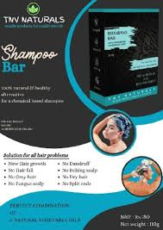

No liquid, no powder.
Dandruff and itching free scalp, in first time usage. Now hair washing is quick and easy.
100% natural and healthy alternative for a chemical based shampoo and hair wash powder.
Perfect combination of 6 natural vegetable oils. sulphate-free shampoo that keeps hair and scalp clear and healthy. for best results use both, hair oil & shampoo bar don’t spoil children's future by using detergent-based shampoos no dandruff it clears , it clears fully. GREAT RESULTS IN FIRST WASH ITSELF you will love your hair. a new feel in your life

Elements Wellness 8 in 1 Hair Conditioner (100ml) MRP

₹451.00
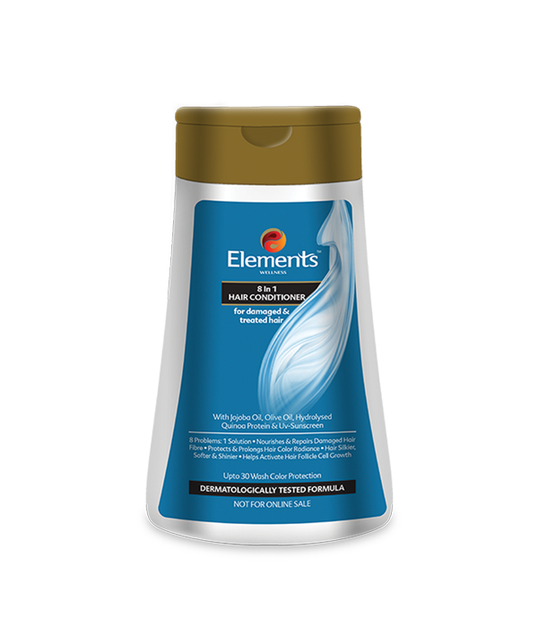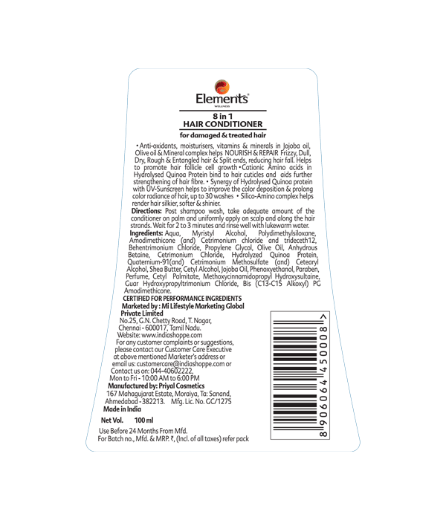

Product Description:
Anti-oxidants, moisturisers, vitamins & minerals in Jojoba oil, Olive oil & Mineral complex helps NOURISH & REPAIR Frizzy, Dull, Dry, Rough & Entangled hair & Split ends, reducing hair fall. Helps to promote hair follicle cell growth. Cationic Amino acids in Hydrolysed Quinoa Protein bind to hair cuticles and aids further strengthening of hair fibre. Synergy of Hydrolysed Quinoa protein with UV-Sunscreen helps to improve the colour deposition & prolong colour radiance of hair, up to 30 washes. Silico-Amino complex helps render hair silkier, softer & shinier.

Net Content:
100ml
Directions for use: Post shampoo wash, take adequate amount of the conditioner on palm and uniformly apply on scalp and along the hair strands. Wait for 2 to 3 minutes and rinse well with lukewarm water.

Ingredients: Aqua, Myristyl Alcohol, Polydimethylsiloxane, Amodimethicone (and) Cetrimonium chloride and trideceth12, Behentrimonium Chloride, Propylene Glycol, Olive Oil, Anhydrous Betaine, Cetrimonium Chloride, Hydrolyzed Quinoa Protein, Quaternium-91(and) Cetrimonium Methosulfate (and) Cetearyl Alcohol, Shea Butter, Cetyl Alcohol, Jojoba Oil, Phenoxyethanol, Paraben, Perfume, Cetyl Palmitate, Methoxycinnamidopropyl Hydroxysultaine, Guar Hydroxypropyltrimonium Chloride, Bis (C13-C15 Alkoxyl) PG Amodimethicone.

Storage: Store in a cool, dry place away from direct sunlight. Keep the container tightly closed when not in use to preserve effectiveness.

Manufactured by: Priyal Cosmetics 167, Mahagujarat Estate, Moraiya, Ta: Sanand, Ahmedabad, Gujarat. M.L. No.: GC/1275

Marketed by: Mi Lifestyle Marketing Global Private Limited No.25, G.N. Chetty Road, T. Nagar, Chennai - 600017, Tamil Nadu.

Shelf Life: Use before 24 months from the date of manufacture.

Additional Information:
Elements Wellness 8 in 1 Hair Conditioner is a comprehensive hair care solution designed to address multiple hair concerns in one product. This advanced conditioner helps reduce hair fall, promotes hair follicle cell growth, and ensures vibrant and long-lasting colour. It nourishes and repairs damaged hair, making it silkier, softer, and shinier. Ideal for weekly use, it provides up to 30 washes of radiance and transformation.
Used for: Reducing hair fall. Promoting hair follicle cell growth. Improves hair radiance. Nourishing and repairing damaged hair. Enhancing hair softness, silkiness, and shine.
Benefits:
Reduces Hair Fall: Helps minimize hair loss and strengthens hair.
Promotes Hair Follicle Growth: Encourages healthy hair follicle cell growth.
Improves Colour Deposition: Enhances the application and retention of hair colour.
Prolongs Colour Radiance: Maintains vibrant hair colour for up to 30 washes.
Nourishes and Repairs: Restores and revitalizes damaged hair.
Enhances Softness and Shine: Leaves hair silkier, softer, and shinier.
Disclaimers: Not recommended for individuals with known allergies to any ingredients.

Elements Wellness Anti-Dandruff Shampoo (200ml) MRP

₹332.00

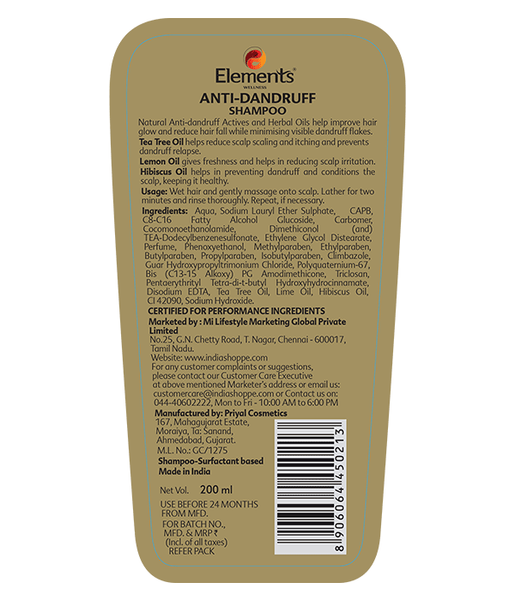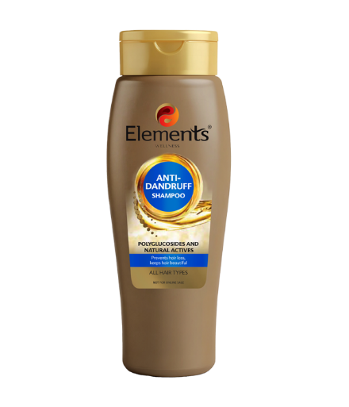

Product Description:
Natural Anti-dandruff Actives and Herbal Oils help improve hair glow and reduce hair fall while minimising visible dandruff flakes. Tea Tree Oil helps reduce scalp scaling and itching and prevents dandruff relapse. Lemon Oil gives freshness and helps in reducing scalp irritation. Hibiscus Oil helps in preventing dandruff and conditions the scalp, keeping it healthy.
Net Content: 200ml

Directions for use: Wet hair and gently massage onto scalp. Lather for two minutes and rinse thoroughly. Repeat, if necessary.

Ingredients: Aqua, Sodium Lauryl Ether Sulphate, CAPB, C8-C16 Fatty Alcohol Glucoside, Carbomer, Cocomonoethanolamide, Dimethiconol (and) TEA-Dodecylbenzenesulfonate, Ethylene Glycol Distearate, Perfume, Phenoxyethanol, Methylparaben, Ethylparaben, Butylparaben, Propylparaben, Isobutylparaben, Climbazole, Guar Hydroxypropyltrimonium Chloride, Polyquaternium-67, Bis (C13-15 Alkoxy) PG Amodimethicone, Triclosan, Pentaerythrityl Tetra-di-t-butyl Hydroxyhydrocinnamate, Disodium EDTA, Tea Tree Oil, Lime Oil, Hibiscus Oil, CI 42090, Sodium Hydroxide.+

Storage: Store in a cool, dry place away from direct sunlight. Keep the bottle tightly closed when not in use.

Manufactured by: Priyal Cosmetics 167, Mahagujarat Estate, Moraiya, Ta: Sanand, Ahmedabad, Gujarat. M.L. No.: GC/1275

Marketed by: Mi Lifestyle Marketing Global Private Limited No.25, G.N. Chetty Road, T. Nagar, Chennai - 600017, Tamil Nadu.

Shelf Life: Use before 24 months from the date of manufacture.

Additional Information:

With the new Elements Wellness Anti Dandruff Shampoo, getting rid of dandruff while achieving smooth and silky hair is no rocket science! This shampoo features natural anti-dandruff properties and contains wonderful herbal oil extracts that enhance the shine and glow of your hair. These herbal oils also help reduce hair fall and eliminate dandruff flakes. The shampoo includes Tea Tree Oil, Lemon Oil, and Hibiscus Oil, making it suitable for all hair types.
Used for: Reducing dandruff. Increasing the shine and glow of the hair.
Benefits: Reduces dandruff flakes. Contains herbal oils like Tea Tree Oil, Lemon Oil, and Hibiscus Oil. Helps in reducing hair fall. Improves hair shine and glow. Suitable for all hair types.
Disclaimers: Not recommended for individuals with known allergies to any of the ingredients.

\
Elements Wellness Complete Care Shampoo (200ml) MRP₹332.00

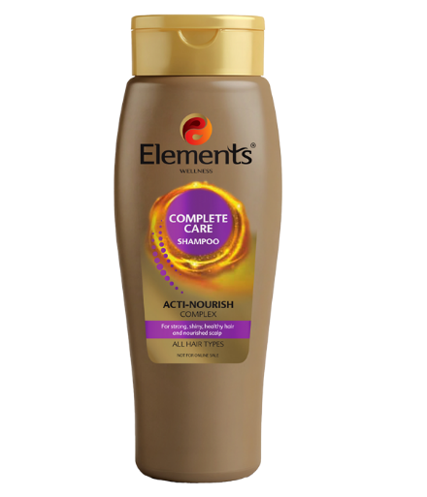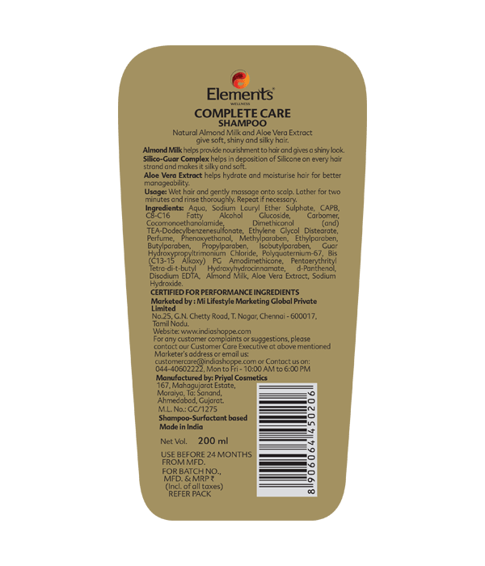

Product Description:
Natural Almond Milk and Aloe Vera Extract give soft, shiny and silky hair. Almond Milk helps provide nourishment to hair and gives a shiny look. Silico-Guar Complex helps in deposition of Silicone on every hair strand and makes it silky and soft. Aloe Vera Extract helps hydrate and moisturise hair for better manageability.
Net Content: 200ml

Directions for use: Wet hair and gently massage onto scalp. Lather for two minutes and rinse thoroughly. Repeat if necessary.

Ingredients: Aqua, Sodium Lauryl Ether Sulphate, CAPB, C8-C16 Fatty Alcohol Glucoside, Carbomer, Cocomonoethanolamide, Dimethiconol (and) TEA-Dodecylbenzenesulfonate, Ethylene Glycol Distearate, Perfume, Phenoxyethanol, Methylparaben, Ethylparaben, Butylparaben, Propylparaben, Isobutylparaben, Guar Hydroxypropyltrimonium Chloride, Polyquaternium-67, Bis (C13-15 Alkoxy) PG Amodimethicone, Pentaerythrityl Tetra-di-t-butyl Hydroxyhydrocinnamate, d-Panthenol, Disodium EDTA, Almond Milk, Aloe Vera Extract, Sodium Hydroxide.

Storage: Store in a cool, dry place away from direct sunlight. Keep the bottle tightly closed when not in use.

Manufactured by: Priyal Cosmetics 167, Mahagujarat Estate, Moraiya, Ta: Sanand, Ahmedabad, Gujarat. M.L. No.: GC/1275

Marketed by: Mi Lifestyle Marketing Global Private Limited No.25, G.N. Chetty Road, T. Nagar, Chennai - 600017, Tamil Nadu.

Shelf Life: Use before 24 months from the date of manufacture.

Additional Information:

Ensure your hair receives complete nourishment with Elements Wellness Complete Care Shampoo. This shampoo is formulated to provide the best nutrition for your hair, keeping it smooth and silky throughout the day. Infused with the Acti-Nourish Complex, it nourishes the scalp and strengthens hair, promoting healthy and shiny locks. Suitable for all hair types, this shampoo is your go-to solution for maintaining beautiful and healthy hair.
Used for: Deeply nourishing hair. Keeping hair smooth and silky. Strengthening hair and promoting shine. Providing essential nutrition to hair.
Benefits: Nourishes hair deeply. Keeps hair smooth and silky. Strengthens hair and promotes shine. Adds nutrition to the hair. Suitable for all hair types.
Disclaimers: Not recommended for individuals with known allergies to any of the ingredients.-

56 HERBS HAIR OIL 100ml

₹320.00

Mix of herbs, flowers, spices and seeds
SAY GOODBYE TO ALL HAIR PROBLEMS – NOW REAL SOLUTION FOR YOU
HERBAL HAIR OIL for MULTIPLE HAIR TREATMENT
CLEAR, HEALTHY HAIR AND SCALP
No hair fall - No dandruff - No itching
WHY OUR HAIR OIL IS VERY SPECIAL?
WORTHABLE AND VALUE FOR YOUR MONEY?
GIVING MAGICAL RESULTS?
A MULTI PURPOSE OIL?
Combination of 56 herbs, flowers, spices, roots and seeds, collected from various parts of india combination of 100 % pure coconut oil and 3 vegetable oils.
WHY OUR HAIR OIL DIFFERENT FROM OTHERS?
To get extraordinary results, we use 100% greenish ingredients. Not using dry powders.
Strictly no preservatives for long life strictly no chemical fragrance for smell and colour .we found our unique combination formula by 4 years of research. for best results use both, hair oil & shampoo bar
Clearing from hair roots. Deep inside, not just outside.
Use now to avoid future worries

56 HERBS HAIR OIL and shampoo bar

